AWS ADVANCE BATCH 1 LU ASSIGNMENT DAY 11

QUESTION 1:
Task 1: Working with SNS
Amazon Simple Notification service is a managed service that provides message delivery from publishers to subscribers.
Screenshot SNS Console:
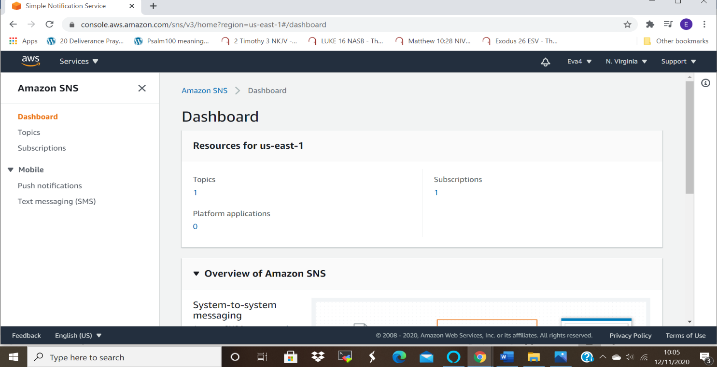

This is the ss of the console showing the subscription:
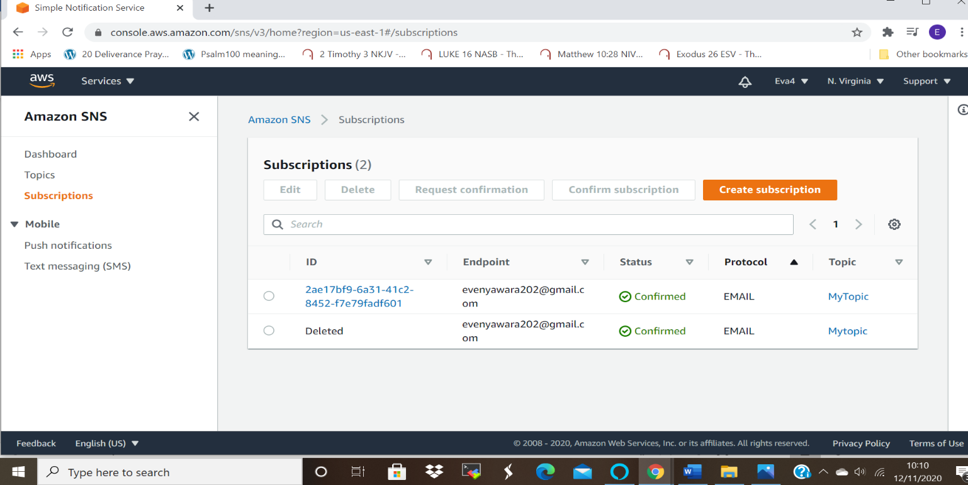

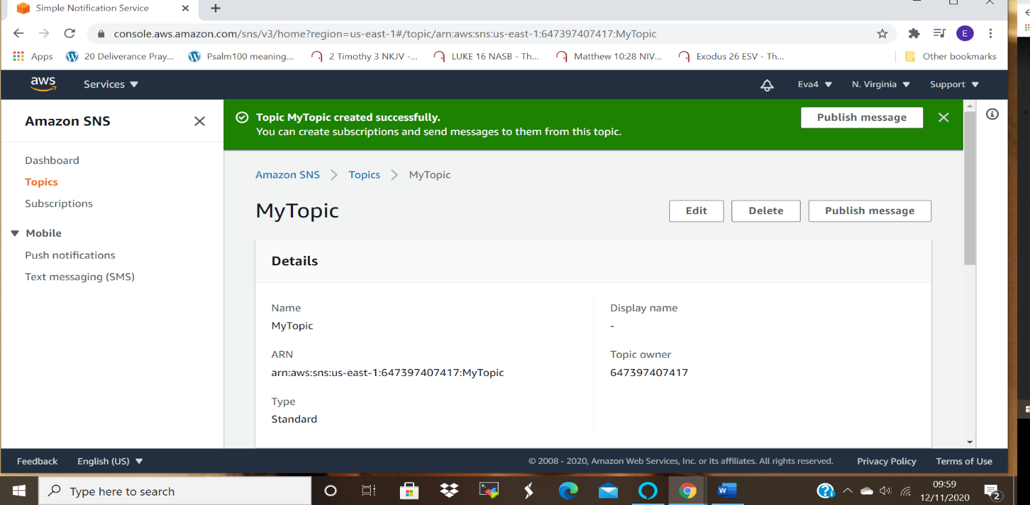

SS2:Inbox with the published message,
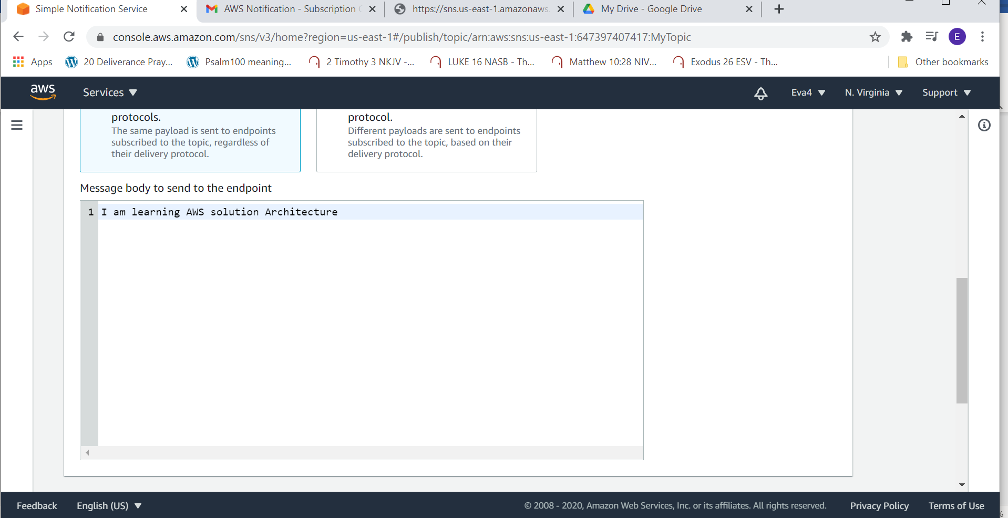

Screen shot for the confirmation of subscription:
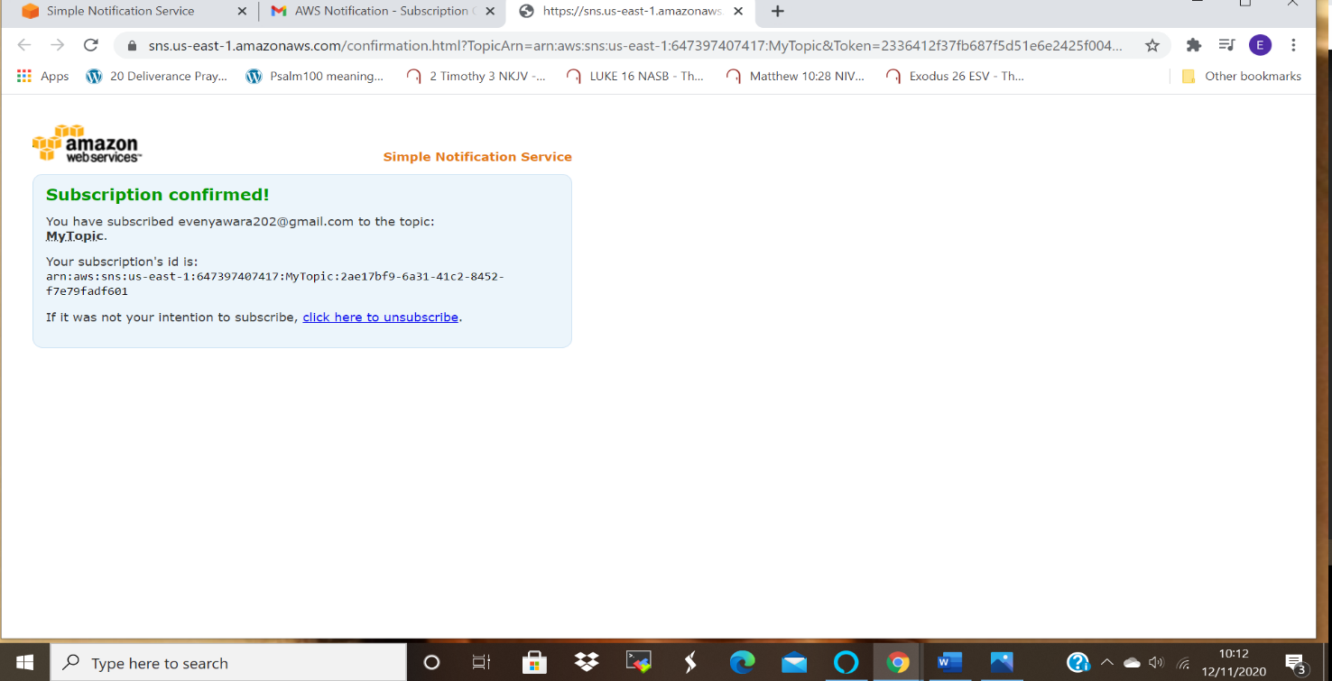

Task 2: Working with SQS
Amazon Simple Queue Service is a fully managed service that enables one to decouple that is separate and scale microservices, distributed systems, and serverless applications.
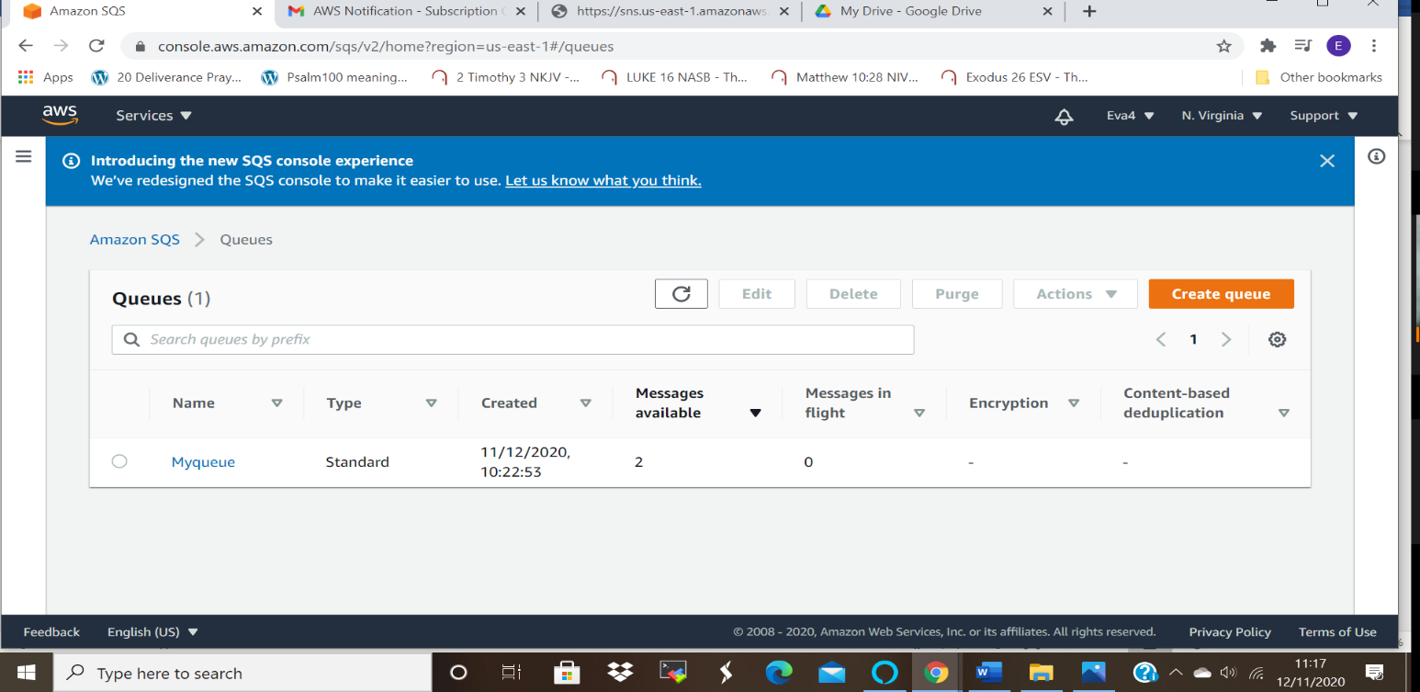
Below is a screenshot of the SQS console:
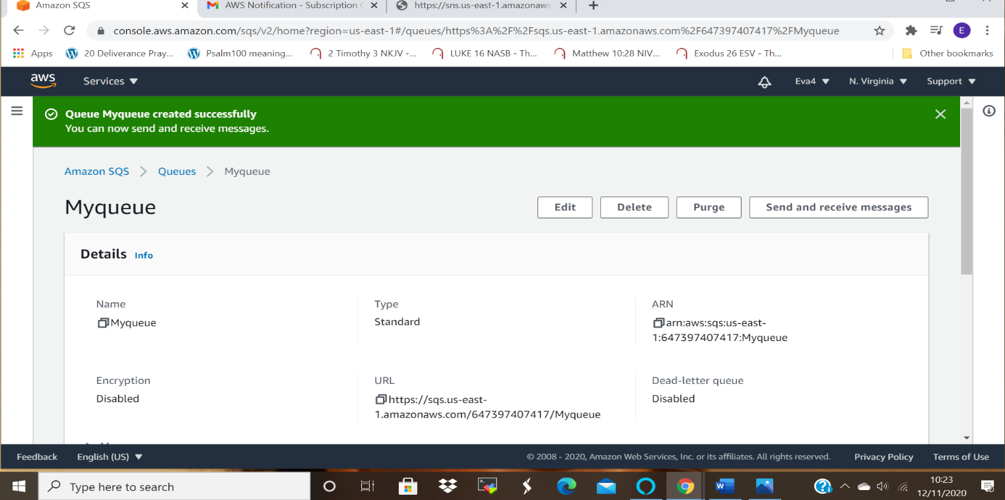

ss2: poll for messages and display message window:
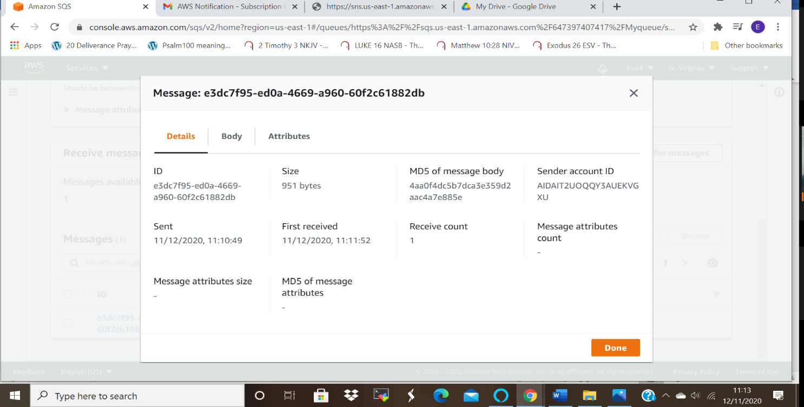

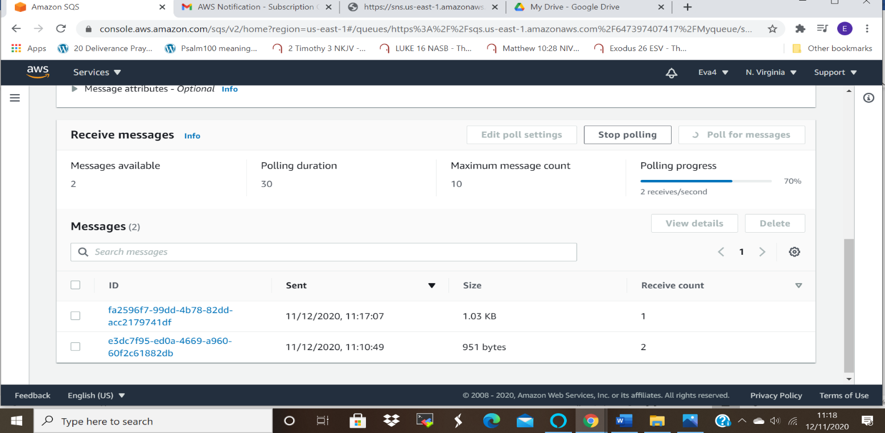

Task 3: Working with SES
Amazon Simple Email Service is a cost-effective, flexible and scalable email service that enable developers to send email from within any application.
ss1: Inbox mail verification:
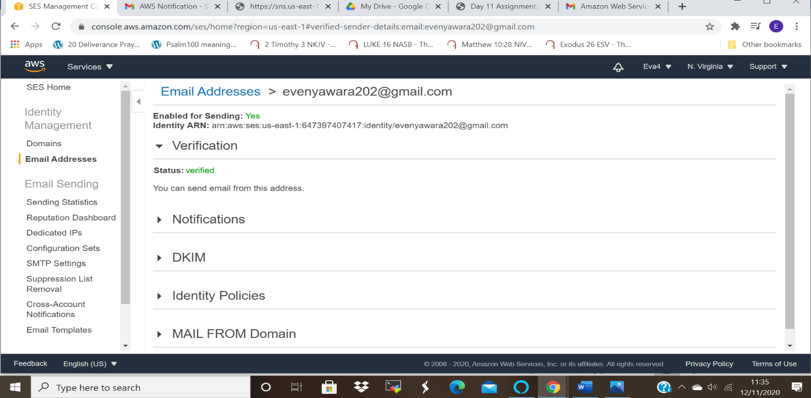

Task 4: TRIGGERING CLOUDWATCH EVENT SNS NOTIFICATION
Amazon Cloud Watch is used for monitoring and observing actionable insights that helps in the running of the applications, it optimizes resource utilization, checks on the operational health of resource.
ss1: ec2 console 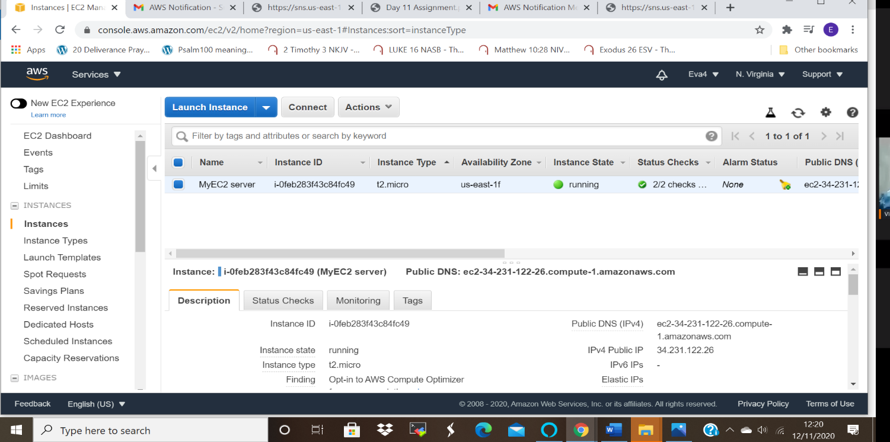
ss2: rule configuration
To configure the rules for triggering the cloudwatch :
Switch to cloudwatch dash board
Click on events then rules
Create rules then you configure, by adding Service name and type of event .
Then add targets.

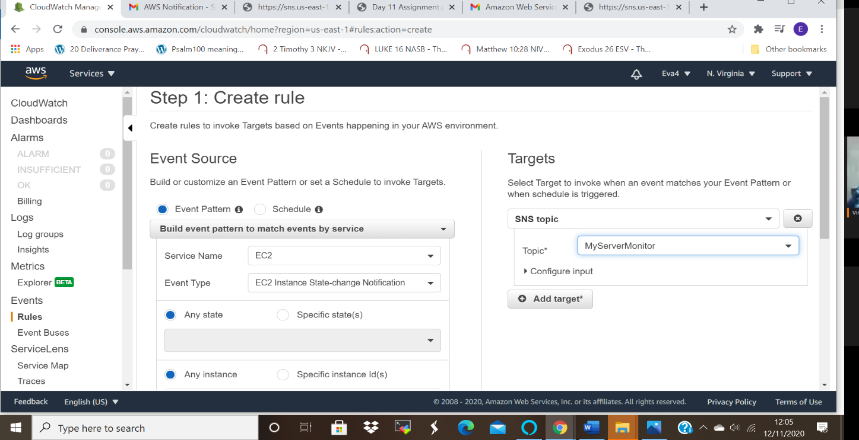

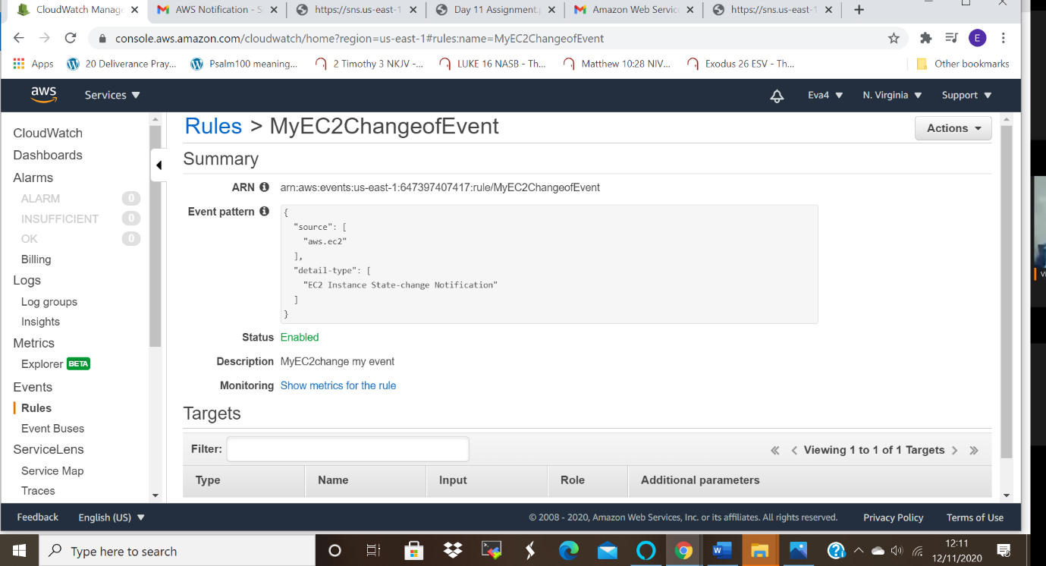

ss3:SNS topic
A new topic of the server was added to the Simple Notification Service Topic dashboard.

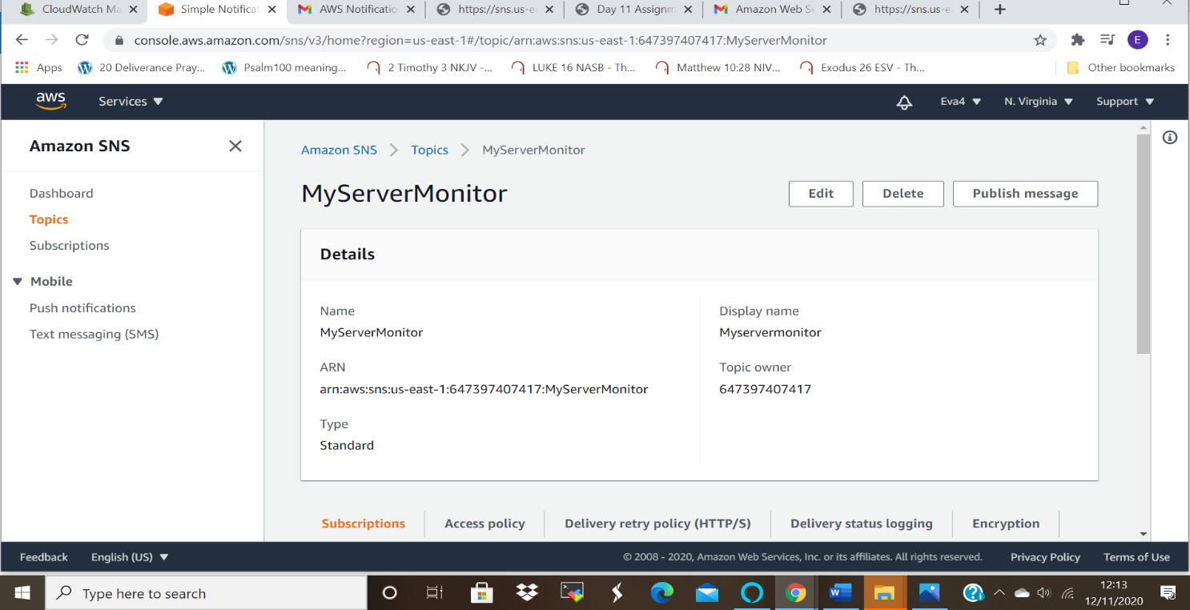
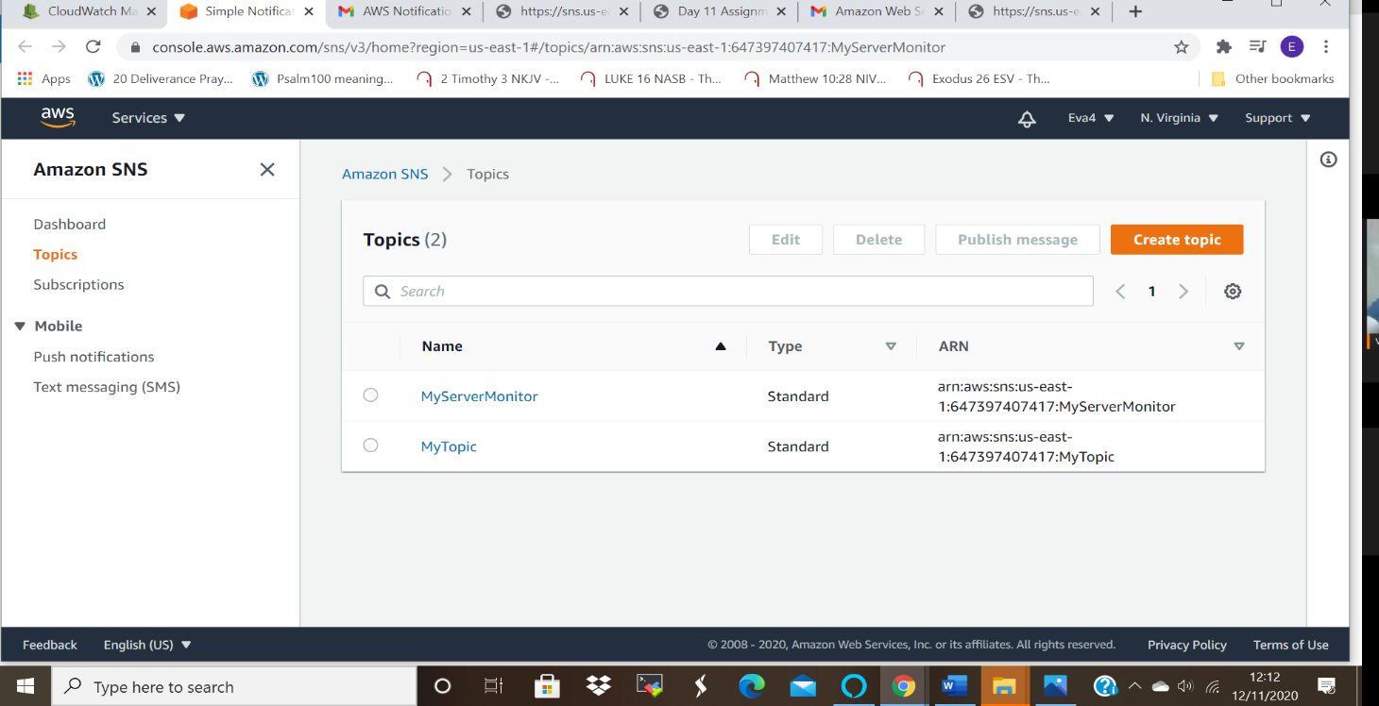

ss4: state change event notification in your mailbox
Screen shot for the confirmation of the new topic created when triggering the cloud watch
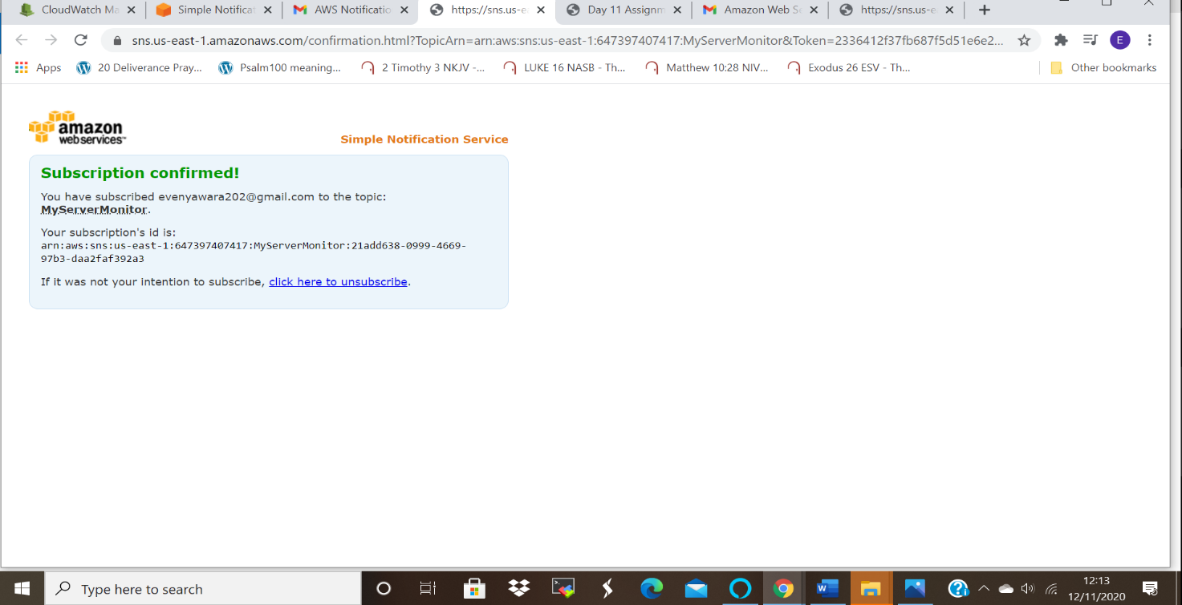

Screen shot for the notification received when the Ec2 server was stopped
